For Text Mining assignment

THREE:

Extract movie reviews for any movie from IMDB and perform sentimental analysis

**Ans :**

**R Code :**

## Text Mining & Sentimental Analysis

########## IMDB Movie Reviews #########

library(rvest)

library(XML)

library(magrittr)

# IMDB Reviews #############################

aurl <- "https://www.imdb.com/title/tt4154796/reviews?ref_=tt_urv"

IMDB_reviews <- NULL

for (i in 1:10){

murl <- read_html(as.character(paste(aurl,i,sep="=")))

rev <- murl %>%

html_nodes(".show-more__control") %>%

html_text()

IMDB_reviews <- c(IMDB_reviews,rev)

}

length(IMDB_reviews)

write.table(IMDB_reviews,"endgame.txt",row.names = F)

getwd()

str(IMDB_reviews)

fin_txt <- IMDB_reviews

library(tm)

fin_corpus<- Corpus(VectorSource(fin_txt))

inspect(fin_corpus[100])

fin_clean<-tm_map(fin_corpus, removePunctuation)

fin_clean<-tm_map(fin_clean, content_transformer(tolower))

fin_clean<-tm_map(fin_clean, removeWords, stopwords("english"))

fin_clean<-tm_map(fin_clean,removeNumbers)

fin_clean<-tm_map(fin_clean, stripWhitespace)

fin_clean<-tm_map(fin_clean, removeWords, c("gameofthrones")) ## clean some words

library(wordcloud)

wordcloud(fin_clean, random.order = F, max.words = 5,colors=rainbow(50))

wordcloud(fin_clean, rot.per=0.5, random.order=TRUE,colors=brewer.pal(8, "Dark2"))

# Term document matrix

# converting unstructured data to structured format using TDM

tdm <- TermDocumentMatrix(fin_clean)

dtm <- t(tdm)

tdm <- as.matrix(tdm)

# Bar plot

w <- rowSums(tdm)

w

w_sub <- subset(w, w >= 20)

w_sub

windows()

barplot(w_sub, las=3, col = rainbow(20))

fin_clean <- tm_map(fin_clean, removeWords, c('apple','air','can','mcds','macbook','product','windows'))

fin_clean <- tm_map(fin_clean, stripWhitespace)

tdm <- TermDocumentMatrix(fin_clean)

tdm <- as.matrix(tdm)

# Word cloud

install.packages("wordcloud")

library(wordcloud)

windows()

wordcloud(words = names(w_sub), freq = w_sub) # wordcloud with only subset of words

w_sub1 <- sort(rowSums(tdm), decreasing = TRUE)

wordcloud(words = names(w_sub1), freq = w_sub1) # all words are considered

windows()

wordcloud(words = names(w_sub1), freq = w_sub1, random.order = F, colors = rainbow(20), scale=c(3,1), rot.per = 0.3)

# lOADING +VE AND -VE dictonaries

pos.words = scan(file.choose(), what="character", comment.char=";") # read-in positive-words.txt

neg.words = scan(file.choose(), what="character", comment.char=";") # read-in negative-words.txt

pos.words = c(pos.words,"wow", "kudos", "hurray") # including our own positive words to the existing list

# Positive wordcloud

pos.matches = match(names(w_sub1), c(pos.words))

pos.matches = !is.na(pos.matches)

freq_pos <- w_sub1[pos.matches]

p_names <- names(freq_pos)

windows()

wordcloud(p_names,freq_pos,scale=c(4,1),colors = rainbow(20))

# Negative wordcloud

neg.matches = match(names(w_sub1), c(neg.words))

neg.matches = !is.na(neg.matches)

freq_neg <- w_sub1[neg.matches]

n_names <- names(freq_neg)

windows()

wordcloud(n_names,freq_neg,scale=c(5,1),colors = brewer.pal(8,"Dark2"))

#### emotion mining ####

install.packages("syuzhet")

library("syuzhet")

library(lubridate,ggplot2)

library(ggplot2)

library(scales)

library(dplyr)

library(reshape2)

x <- get_nrc_sentiment(fin_txt)

head(x,n=5)

fin_txt[4]

get_nrc_sentiment('happy')

get_nrc_sentiment('boring')

get_sentiment('boring',method="afinn")

get_sentiment('happy',method="afinn")

#each sentences by eight

example<-get_sentences(fin_txt)

nrc_data<-get_nrc_sentiment(example)

# Bar plot for emotion mining

windows()

barplot(colSums(nrc_data), las = 1, col = rainbow(10), ylab = 'Count', main = 'Emotion scores')

sentiment_vector<-get_sentiment(example,method="bing")

sentiment_afinn<-get_sentiment(example,method="afinn")

sentiment_nrc<-get_sentiment(example,method="nrc")

sum(sentiment_afinn)

mean(sentiment_afinn)

summary(sentiment_afinn)

windows()

plot(sentiment_vector,type='l',maim='Plot trajectory',xlab='Narative time',ylab='Emotional valence')

abline(h=0,color='red')

plot(

sentiment_vector,

type="h",

main="Example Plot Trajectory",

xlab = "Narrative Time",

ylab= "Emotional Valence"

)

##Shape smoothing and normalization using a Fourier based transformation and low pass filtering is achieved using the get_transformed_values function as shown below.

ft_values <- get_transformed_values(

sentiment_vector,

low_pass_size = 3,

x_reverse_len = 100,

padding_factor = 2,

scale_vals = TRUE,

scale_range = FALSE

)

plot(

ft_values,

type ="l",

main ="IMDB Endgame Movie Reviews using Transformed values",

xlab = "Narrative Time",

ylab = "Emotional Valence",

col = "red"

)

#Most Negative and Positive reviews

negative<-example[which.min(sentiment_vector)]

positive<-example[which.max(sentiment_vector)]

################################################

my_example_text <- "I begin this story with a neutral statement.

Basically this is a very silly test.

You are testing the Syuzhet package using short, inane sentences.

I am actually very happy today.

I have finally finished writing this package.

Tomorrow I will be very sad.

I won't have anything left to do.

I might get angry and decide to do something horrible.

I might destroy the entire package and start from scratch.

Then again, I might find it satisfying to have completed my first R package.

Honestly this use of the Fourier transformation is really quite elegant.

You might even say it's beautiful!"

#x-axis represents the passage of time from the beginning to the end of the text, and the y-axis measures the degrees of positive and negative sentiment

s_v <- get_sentences(my_example_text)

s_v_sentiment <- get_sentiment(s_v)

plot(

s_v_sentiment,

type="l",

main="Example Plot Trajectory",

xlab = "Narrative Time",

ylab= "Emotional Valence"

)

**Results :**

> length(IMDB_reviews)

[1] 450

> write.table(IMDB_reviews,"endgame.txt",row.names = F)

> getwd()

[1] "D:/Data Science/Excelr/Assignments/Assignment/Text Mining"

> str(IMDB_reviews)

chr [1:450] "There is no way that I could describe my emotions for this movie. I'm totally speechless. I haven't laughed (ev"| __truncated__ ...

> fin_txt <- IMDB_reviews

> fin_corpus<- Corpus(VectorSource(fin_txt))

> inspect(fin_corpus[100])

<<SimpleCorpus>>

Metadata: corpus specific: 1, document level (indexed): 0

Content: documents: 1

[1]

> View(fin_corpus)

> tdm <- TermDocumentMatrix(fin_clean)

> dtm <- t(tdm)

> tdm <- as.matrix(tdm)

> # Bar plot

> w <- rowSums(tdm)

> w

abs absolute accept accomplish acting

10 10 10 10 20

action actually alerteven already also

60 50 10 30 130

amazing america arrived arrow asgard

50 80 20 10 10

avengers awhile back backim badass

200 10 130 10 10

balance behind best big bring

10 30 60 50 40

brothers can capable captain careful

10 220 10 170 10

cgi character characters clapping completely

50 150 110 10 20

cried crying dance depressed describe

10 30 10 10 10

deserved didnt disappointed dont duh

10 170 20 90 10

emotion emotional emotions endgame ending

20 40 10 270 80

enthusiasm epic even ever everything

10 70 210 40 120

excitement expected experience face fat

10 20 10 30 10

father felt fight finally finger

20 70 120 40 10

forever forget full fully get

10 30 30 30 100

give gives god gonna goosebumps

70 40 40 50 10

got great guy happiness happy

60 90 60 10 30

havent hawkeye heart herealso hero

10 60 10 10 30

hes honest hours infinity jarvis

60 30 70 230 10

joke joy just kill killed

60 20 300 30 20

kinda know laughed laughing left

30 120 10 10 70

lets life like line long

80 50 340 50 20

loss love man many marathon

20 40 130 150 10

marvel matter mean message met

250 20 30 20 10

might miss missed moment movie

30 30 10 10 540

movies much need now outstanding

140 130 20 110 10

past peggy people perfect perfection

80 60 80 20 10

performance person powerful pure quantum

10 10 20 30 10

randomly reallife really realm remember

20 10 210 10 20

responsible russo sadness sake save

10 10 10 10 40

scene screaming seconds see self

130 10 40 50 10

shape shocked shot showed slap

10 10 20 30 10

snapping speechless speechlessthis state still

20 20 10 10 40

stomach story storytelling strong strongest

10 260 10 30 10

stunning superhero takesgo taking tears

10 50 10 20 10

thanos thatspoiler theater thinking thisit

370 10 10 20 10

thisready thor though thunder told

10 220 60 30 40

tony toowhen totally treat trying

110 10 10 10 40

visually want war warm watch

10 80 190 10 90

watching way went whatever whole

50 100 40 20 50

will win world years youll

50 40 50 60 10

abilities able actor add agree

10 40 20 10 10

almost ancient annoying another anyone

40 10 10 100 10

around balanced banners banteri barely

50 10 10 10 10

beautifulthe better bit bizarre black

10 40 10 20 20

brought buzz cant cap care

10 20 110 120 20

cares change changing cinema clever

10 40 20 40 40

convenient convenienti conversation couldnt created

30 10 10 40 40

creates creating creeping cut day

30 40 10 60 30

deal deaths defeat deus doesnt

10 10 60 20 90

easily elses elsethere end enjoyable

20 10 10 190 10

enlightened entire erasing essentially everyone

10 30 10 10 60

explain fan feel fingers first

30 30 60 20 70

found franchise game gamora gauntlet

40 40 40 20 60

glaring goes gotg grief hand

10 30 20 10 20

handedly happens hate hell hilarious

10 10 60 30 20

history hold hulk impossibly inconsistencies

30 20 110 10 20

inevitably intentional iron kills knowing

10 10 50 10 10

lake loki loved machina made

10 10 80 20 80

magically make meant meets mistake

10 110 30 10 10

mjollnir naive never new nicely

20 10 120 40 10

okay one onethe original others

20 220 10 40 40

parallelsso particularly perhaps pfft plot

10 20 20 10 80

present pretty prevent probably problem

10 30 10 30 30

questions quill reaction real reallykilling

30 10 20 50 10

references relationship renner reviews rich

10 20 10 30 10

right said say selfish send

50 50 120 10 10

sent serious service show single

10 10 20 40 30

sitting snaps someone spent stark

20 10 40 10 30

started stay stick stones stop

10 10 10 60 10

stormbringer stuck stuff stupid suddenly

20 10 40 10 40

sure surprising swinging theres theyre

50 20 10 10 20

think thors thought time timeline

90 20 30 280 90

timelines times touch toy travel

20 40 10 10 90

try unfortunatelythe universe universealso walking

30 10 60 10 10

ways widow without wrap yet

20 30 60 20 60

anticipated appears areas aspects battle

10 20 10 20 70

become beginning biggest case center

30 60 20 20 10

certain certainly cinematic clue comes

10 10 20 10 40

comfortably comparison concern course critical

10 10 20 30 10

details disappearedon disappointment discussed distress

10 10 30 10 10

divided drags effects errors events

10 10 30 10 20

everyones example expectation expecting familyof

10 30 10 30 10

far fast film films final

30 30 140 80 60

finale find fore forward front

20 30 10 40 10

future general getting good happen

20 10 40 140 30

head heavy heroes higher highlights

30 10 30 20 10

homage home important included insignificant

10 30 50 10 10

last lee legend logic makes

80 10 10 10 80

marvels meaningful meaningless means minutes

10 10 10 50 60

moreover moves necessary normally outside

10 10 20 20 10

overshadowed packed partsavengers period play

10 10 10 10 20

pointlastly predicament probability put realize

10 10 10 20 10

recent related rest rising role

20 20 20 10 10

scenes separate shouldnt slight slower

50 10 20 20 10

small spiderman stage stan stories

20 10 10 10 10

struggle successful surprise team tempo

10 30 10 40 10

tenyear terms theories threehour turn

10 10 10 10 10

two undoubtedly visual waited wonder

90 10 10 10 20

wondered youre anything applauded arent

10 20 50 10 30

avoid checked clap crowd crowds

10 10 10 10 10

dutch free going hands isthe

20 10 160 10 10

mascara opinion passionate row seeing

10 40 10 10 30

smudged spoiler spoilers stood thats

10 10 10 10 50

usually witnessed covered direction flaws

20 10 10 20 10

franchises funny holes however humor

10 20 50 10 10

isnt leads lines main making

50 10 20 20 40

mcu misses moments overall prefer

50 10 30 10 10

shocking snapped solid surprises suspense

10 10 10 10 10

amusing angry bad beautiful beloved

10 20 100 10 10

boring build building caps comic

30 10 30 10 20

cry damn decent destroy disappointededit

10 10 10 30 10

downvote dozens dramatic due ended

10 10 20 10 10

enjoyed era fact fanboys fans

20 10 10 10 10

filled gave hype jokes least

10 10 10 10 60

let masterpiece maybe meh minute

40 10 20 10 10

next notch nothing pathetic place

20 10 50 30 20

planned plus possible previous proper

10 10 10 40 10

relief saying start theaters top

10 50 40 10 20

treated unpopular uses worst wouldnt

10 10 20 30 10

writers yeah army elsewhere energy

100 10 10 10 10

happened huge ideology instead milion

30 20 10 30 10

opened portal saving simply strange

10 30 50 10 50

timestone took wants writing actors

10 10 10 30 20

exception handful lacks outright pointless

10 10 10 10 20

thus belong cheers dark days

10 10 10 10 10

heroic joker kids knight nolans

20 10 10 10 10

old overrated philipses politics super

70 10 10 10 50

unless almighty avenger bifrost cheese

10 10 10 10 10

chunks commanding conclusionwell directionshould doubt

10 10 10 10 10

else existence forwarding funi goodthe

30 10 10 10 10

hollywood imo isjust lack large

10 10 10 20 10

lethargic looking money non pace

10 30 20 10 10

passing progression sense shambles slow

10 10 20 10 30

something superpowersthe title total warthat

30 10 10 20 10

workthey worse admiration admirationrespect airbut

10 30 10 10 10

always alzheimers antics anymore appearing

30 10 10 30 10

approaching arrives asking assumed attempting

10 10 10 10 10

attention audience avenging away ball

10 30 10 60 10

battling beatings becomes begins believed

10 10 20 10 10

bias blossoming bludgeon bouncing break

10 10 10 10 10

bucky buffoonwe bumbling butt came

40 10 10 10 20

camera capt carried carter cat

10 10 10 10 10

chance chest child choke choreographed

10 10 10 10 10

civil clearly click clip combatants

20 10 10 10 10

come comics coming commenting complement

10 10 10 10 10

complicated concentrate confidence consequences consider

10 10 10 10 20

considered considering contend correctness corrupted

10 20 10 10 10

create creation credible creep criticism

10 10 10 10 10

cull damage dangerous decided deeper

10 10 10 20 10

defeatable defeated deliberately demands desire

10 20 10 10 30

development directed directly directors disappointedi

20 10 20 40 10

discarded dispatched dominant done drinking

10 10 10 20 10

driven dropped earlier earned earnt

10 10 10 20 10

easy educate effort embarrassing empathise

10 10 20 10 10

engagement engineers ensure entertainment entrance

10 10 10 20 10

established evil evolution eye falcon

10 20 10 10 20

fear feels fell female fights

20 20 20 20 20

flashing flitting focus foe foil

10 10 20 10 10

fool form former frustrations fuelled

10 20 10 10 10

fundamentally furys gamorra gathering geography

20 10 10 10 10

gimmick gimmicky given grabs ground

10 10 10 10 10

guardians guys guysand guythis hadnt

10 50 10 10 10

half handshake handshakesteve hard hasnt

20 10 10 40 30

hed hence henchman heres herobut

10 20 10 10 10

heroismlikewise hey high highlight himits

10 10 20 10 10

holding hole hoped humiliation iconic

10 10 20 10 10

identified immediately imminent impressive incredible

10 10 10 10 10

initially integrity intuitively invested irrelevant

10 10 10 10 10

ive journey kicks killing knew

20 10 10 10 20

knife lacking lazy learnt leaves

10 10 20 10 10

letter lights likewise linearity literally

10 10 10 20 30

look loop maintained maintaining makers

20 10 10 10 10

manage manifest marry marty massed

20 10 10 10 10

massive messing minded mjolnir motivated

10 10 10 30 10

must muttering needed needs obviously

10 10 20 10 10

onin open opportunityinfinity origin pain

10 20 10 10 10

part peoplein physical pleasing pointlessthe

10 10 10 10 10

political possession post pot power

10 10 20 10 10

powered prepared preparing primordial product

10 30 10 10 20

pssed pull punch punches punchfor

10 10 20 10 10

pyrotechnics quality quest question quickly

10 10 20 10 20

rage ragnarok ranks rather reached

10 10 10 10 10

reaching realise recognise recognised redemption

10 10 10 10 20

reek relatable remaining removed render

10 10 10 10 10

repeated replaced rescue respect retrofitting

10 10 10 10 10

revengeto reversing ridiculing roll rounded

10 10 10 10 10

rules run running russos sacrifice

20 10 10 10 40

sacrificed sakelike sam saw scarlet

10 10 30 10 40

seem seemingly seems seen seenin

20 20 30 40 10

selfindulgent selfthe senseiw sensitive serum

10 10 10 10 20

set sexy shadow shame sharon

40 10 10 10 10

shield showcases showing shown shows

20 10 10 30 50

silly smash smashes smashing smile

10 20 20 10 20

soaring social soldier somehow sorry

10 10 40 10 10

space stakes standing starts station

10 10 10 20 10

step steve stoic stone stonesyet

10 120 10 20 10

storieshaving stormbreaker strength studio success

10 30 10 10 10

succumbed suffering superhuman supplied surei

10 10 10 10 10

sympathetic take taken takes talking

10 50 20 20 10

tazer telling tension terrified thatim

10 10 10 10 10

[ reached getOption("max.print") -- omitted 344 entries ]

> w_sub <- subset(w, w >= 20)

> w_sub

acting action actually already also amazing

20 60 50 30 130 50

america arrived avengers back behind best

80 20 200 130 30 60

big bring can captain cgi character

50 40 220 170 50 150

characters completely crying didnt disappointed dont

110 20 30 170 20 90

emotion emotional endgame ending epic even

20 40 270 80 70 210

ever everything expected face father felt

40 120 20 30 20 70

fight finally forget full fully get

120 40 30 30 30 100

give gives god gonna got great

70 40 40 50 60 90

guy happy hawkeye hero hes honest

60 30 60 30 60 30

hours infinity joke joy just kill

70 230 60 20 300 30

killed kinda know left lets life

20 30 120 70 80 50

like line long loss love man

340 50 20 20 40 130

many marvel matter mean message might

150 250 20 30 20 30

miss movie movies much need now

30 540 140 130 20 110

past peggy people perfect powerful pure

80 60 80 20 20 30

randomly really remember save scene seconds

20 210 20 40 130 40

see shot showed snapping speechless still

50 20 30 20 20 40

story strong superhero taking thanos thinking

260 30 50 20 370 20

thor though thunder told tony trying

220 60 30 40 110 40

want war watch watching way went

80 190 90 50 100 40

whatever whole will win world years

20 50 50 40 50 60

able actor almost another around better

40 20 40 100 50 40

bizarre black buzz cant cap care

20 20 20 110 120 20

change changing cinema clever convenient couldnt

40 20 40 40 30 40

created creates creating cut day defeat

40 30 40 60 30 60

deus doesnt easily end entire everyone

20 90 20 190 30 60

explain fan feel fingers first found

30 30 60 20 70 40

franchise game gamora gauntlet goes gotg

40 40 20 60 30 20

hand hate hell hilarious history hold

20 60 30 20 30 20

hulk inconsistencies iron loved machina made

110 20 50 80 20 80

make meant mjollnir never new okay

110 30 20 120 40 20

one original others particularly perhaps plot

220 40 40 20 20 80

pretty probably problem questions reaction real

30 30 30 30 20 50

relationship reviews right said say service

20 30 50 50 120 20

show single sitting someone stark stones

40 30 20 40 30 60

stormbringer stuff suddenly sure surprising theyre

20 40 40 50 20 20

think thors thought time timeline timelines

90 20 30 280 90 20

times travel try universe ways widow

40 90 30 60 20 30

without wrap yet appears aspects battle

60 20 60 20 20 70

become beginning biggest case cinematic comes

30 60 20 20 20 40

concern course disappointment effects events example

20 30 30 30 20 30

expecting far fast film films final

30 30 30 140 80 60

finale find forward future getting good

20 30 40 20 40 140

happen head heroes higher home important

30 30 30 20 30 50

last makes means minutes necessary normally

80 80 50 60 20 20

play put recent related rest scenes

20 20 20 20 20 50

shouldnt slight small successful team two

20 20 20 30 40 90

wonder youre anything arent dutch going

20 20 50 30 20 160

opinion seeing thats usually direction funny

40 30 50 20 20 20

holes isnt lines main making mcu

50 50 20 20 40 50

moments angry bad boring building comic

30 20 100 30 30 20

destroy dramatic enjoyed least let maybe

30 20 20 60 40 20

next nothing pathetic place previous saying

20 50 30 20 40 50

start top uses worst writers happened

40 20 20 30 100 30

huge instead portal saving strange writing

20 30 30 50 50 30

actors pointless heroic old super else

20 20 20 70 50 30

lack looking money sense slow something

20 30 20 20 30 30

total worse always anymore audience away

20 30 30 30 30 60

becomes bucky came civil consider considering

20 40 20 20 20 20

decided defeated desire development directly directors

20 20 30 20 20 40

done earned effort entertainment evil falcon

20 20 20 20 20 20

fear feels fell female fights focus

20 20 20 20 20 20

form fundamentally guys half hard hasnt

20 20 50 20 40 30

hence high hoped ive knew lazy

20 20 20 20 20 20

linearity literally look manage mjolnir needed

20 30 20 20 30 20

open post prepared product punch quest

20 20 30 20 20 20

quickly redemption rules sacrifice sam scarlet

20 20 20 40 30 40

seem seemingly seems seen serum set

20 20 30 40 20 40

shield shown shows smash smashes smile

20 30 50 20 20 20

soldier starts steve stone stormbreaker take

40 20 120 20 30 50

taken takes thing threat together token

20 20 20 20 40 20

tonys towards travelling understand wakanda wanted

40 20 20 20 30 20

wasted well wilson witch work written

30 30 20 40 20 30

wrote year bother hour point ran

20 20 20 20 40 30

turned cameos confusing gets longer ones

20 20 20 30 20 20

wrong ironman moviethe waste arc breaker

40 40 20 20 20 20

dad die doctor fly friend headed

40 20 30 20 20 20

ignore looked parents plan powers retire

30 20 20 20 20 20

says situation south steves storm storyline

20 20 20 20 20 20

talk things cure fighting gamma mom

30 20 20 30 20 20

rays regenerate

20 20

> x <- get_nrc_sentiment(fin_txt)

> head(x,n=5)

anger anticipation disgust fear joy sadness surprise trust negative positive

1 10 16 8 12 20 11 10 16 17 32

2 6 10 4 9 7 8 7 11 18 18

3 4 10 4 7 6 8 5 11 11 20

4 0 0 0 0 0 0 0 0 0 0

5 0 0 0 0 0 0 0 0 0 0

> fin_txt[4]

[1] ""

> get_nrc_sentiment('happy')

anger anticipation disgust fear joy sadness surprise trust negative positive

1 0 1 0 0 1 0 0 1 0 1

> get_nrc_sentiment('boring')

anger anticipation disgust fear joy sadness surprise trust negative positive

1 0 0 0 0 0 0 0 0 1 0

> get_sentiment('boring',method="afinn")

[1] -3

> get_sentiment('happy',method="afinn")

[1] 3

> sentiment_vector<-get_sentiment(example,method="bing")

> sentiment_afinn<-get_sentiment(example,method="afinn")

> sentiment_nrc<-get_sentiment(example,method="nrc")

> sum(sentiment_afinn)

[1] 1280

> mean(sentiment_afinn)

[1] 0.3240506

> summary(sentiment_afinn)

Min. 1st Qu. Median Mean 3rd Qu. Max.

-9.0000 -1.0000 0.0000 0.3241 2.0000 15.0000

**Plots :**

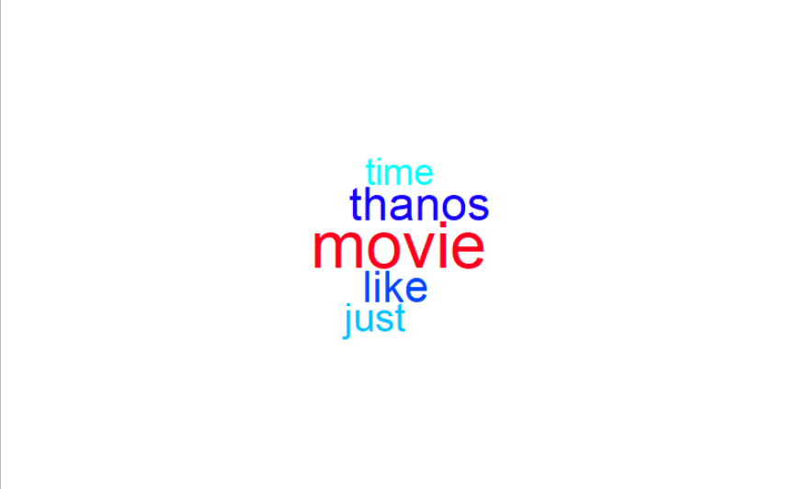

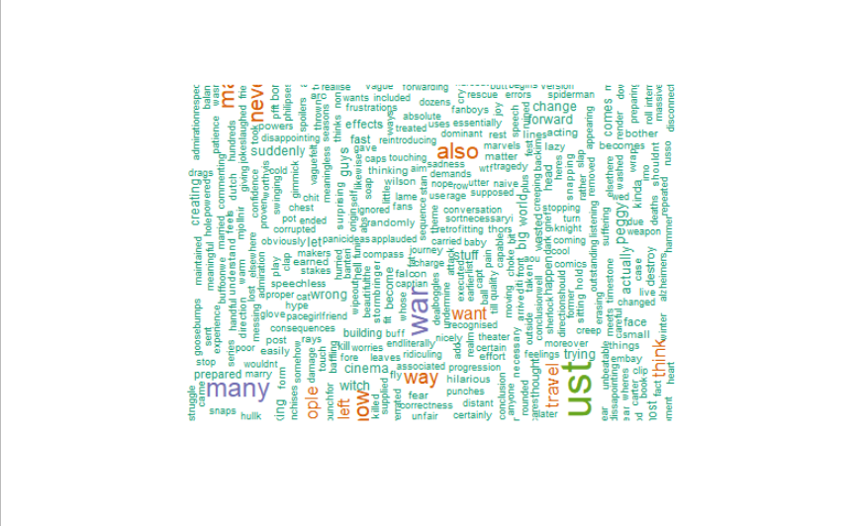

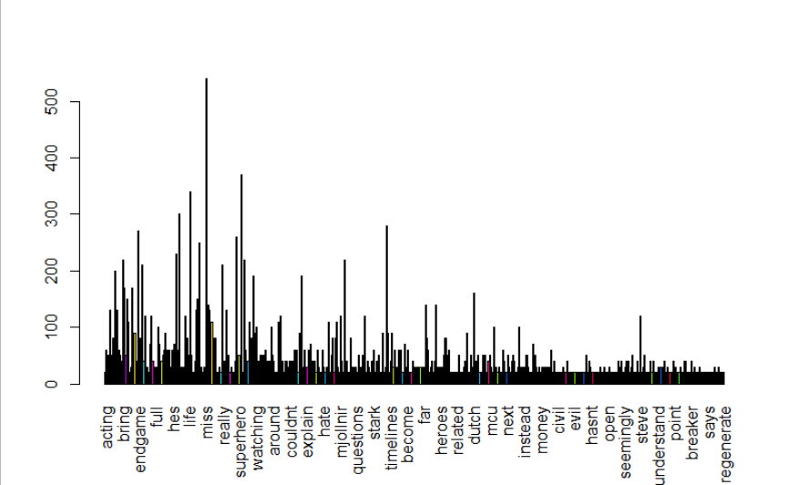

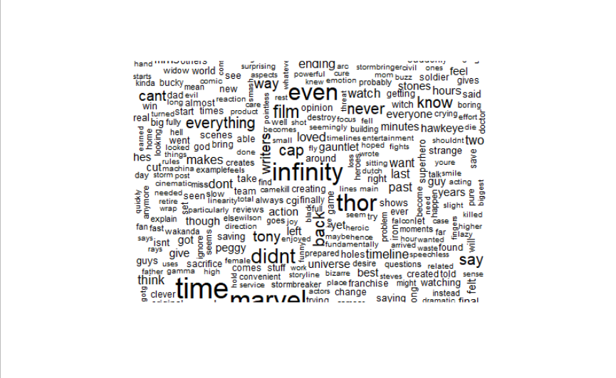

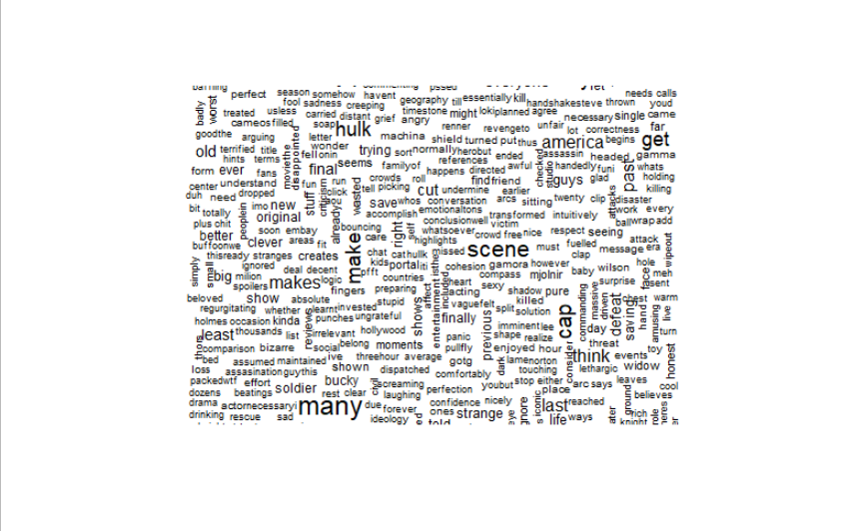

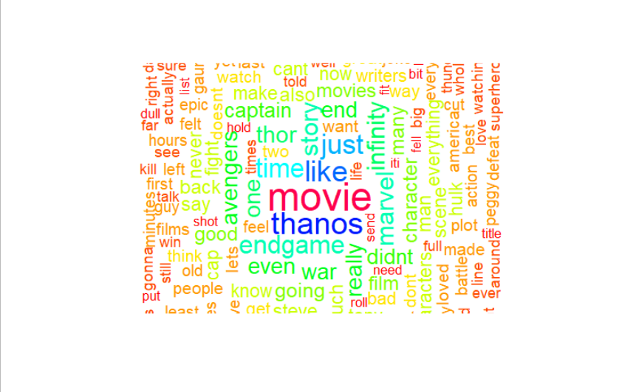

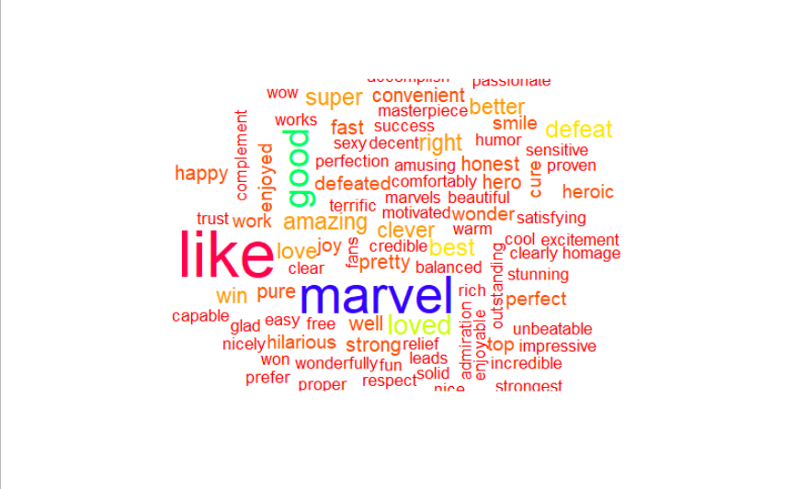

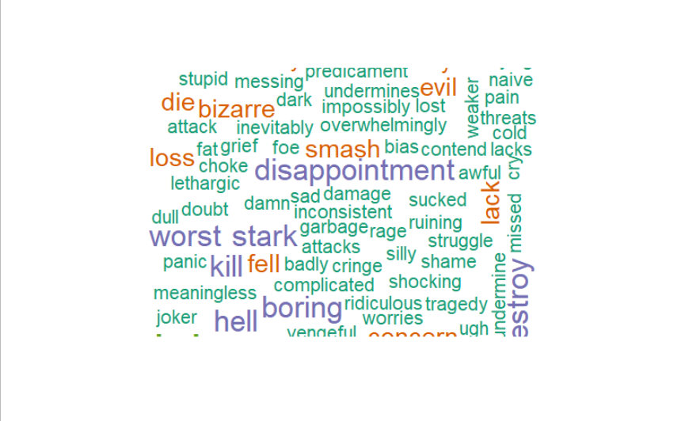

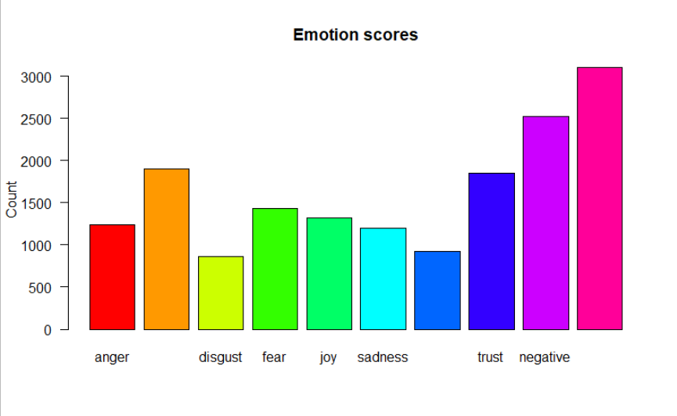

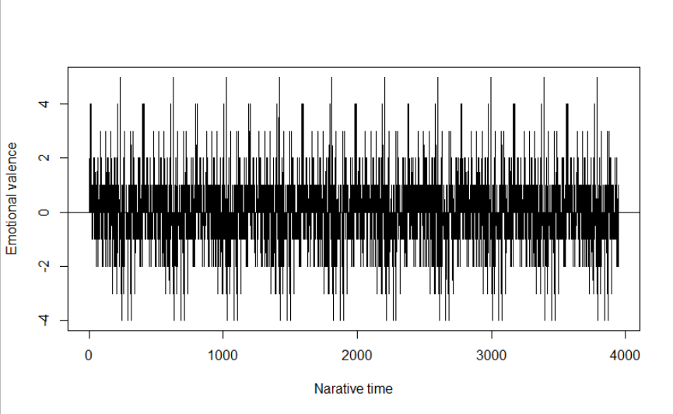

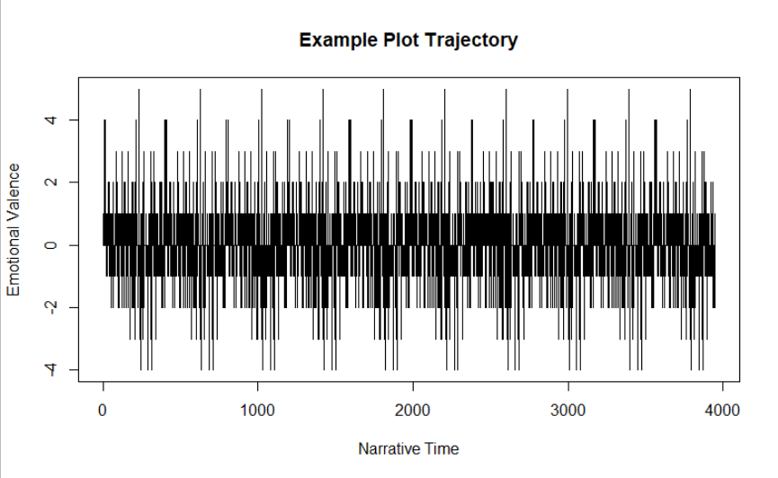

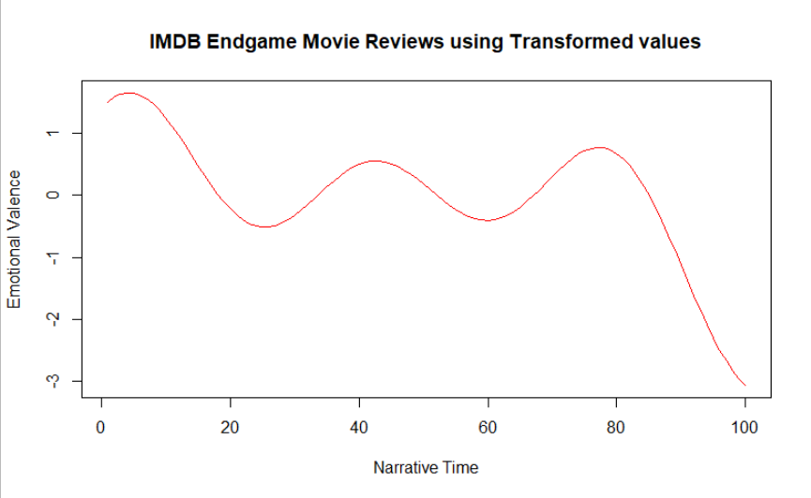

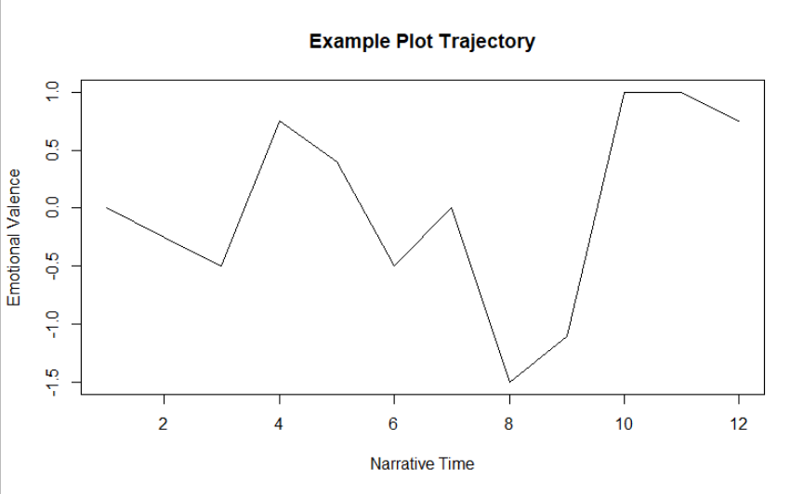

**Inference :**

The mean sentiment value is of 0.32. Hence, we can infer that the reviews are mostly on positive side.